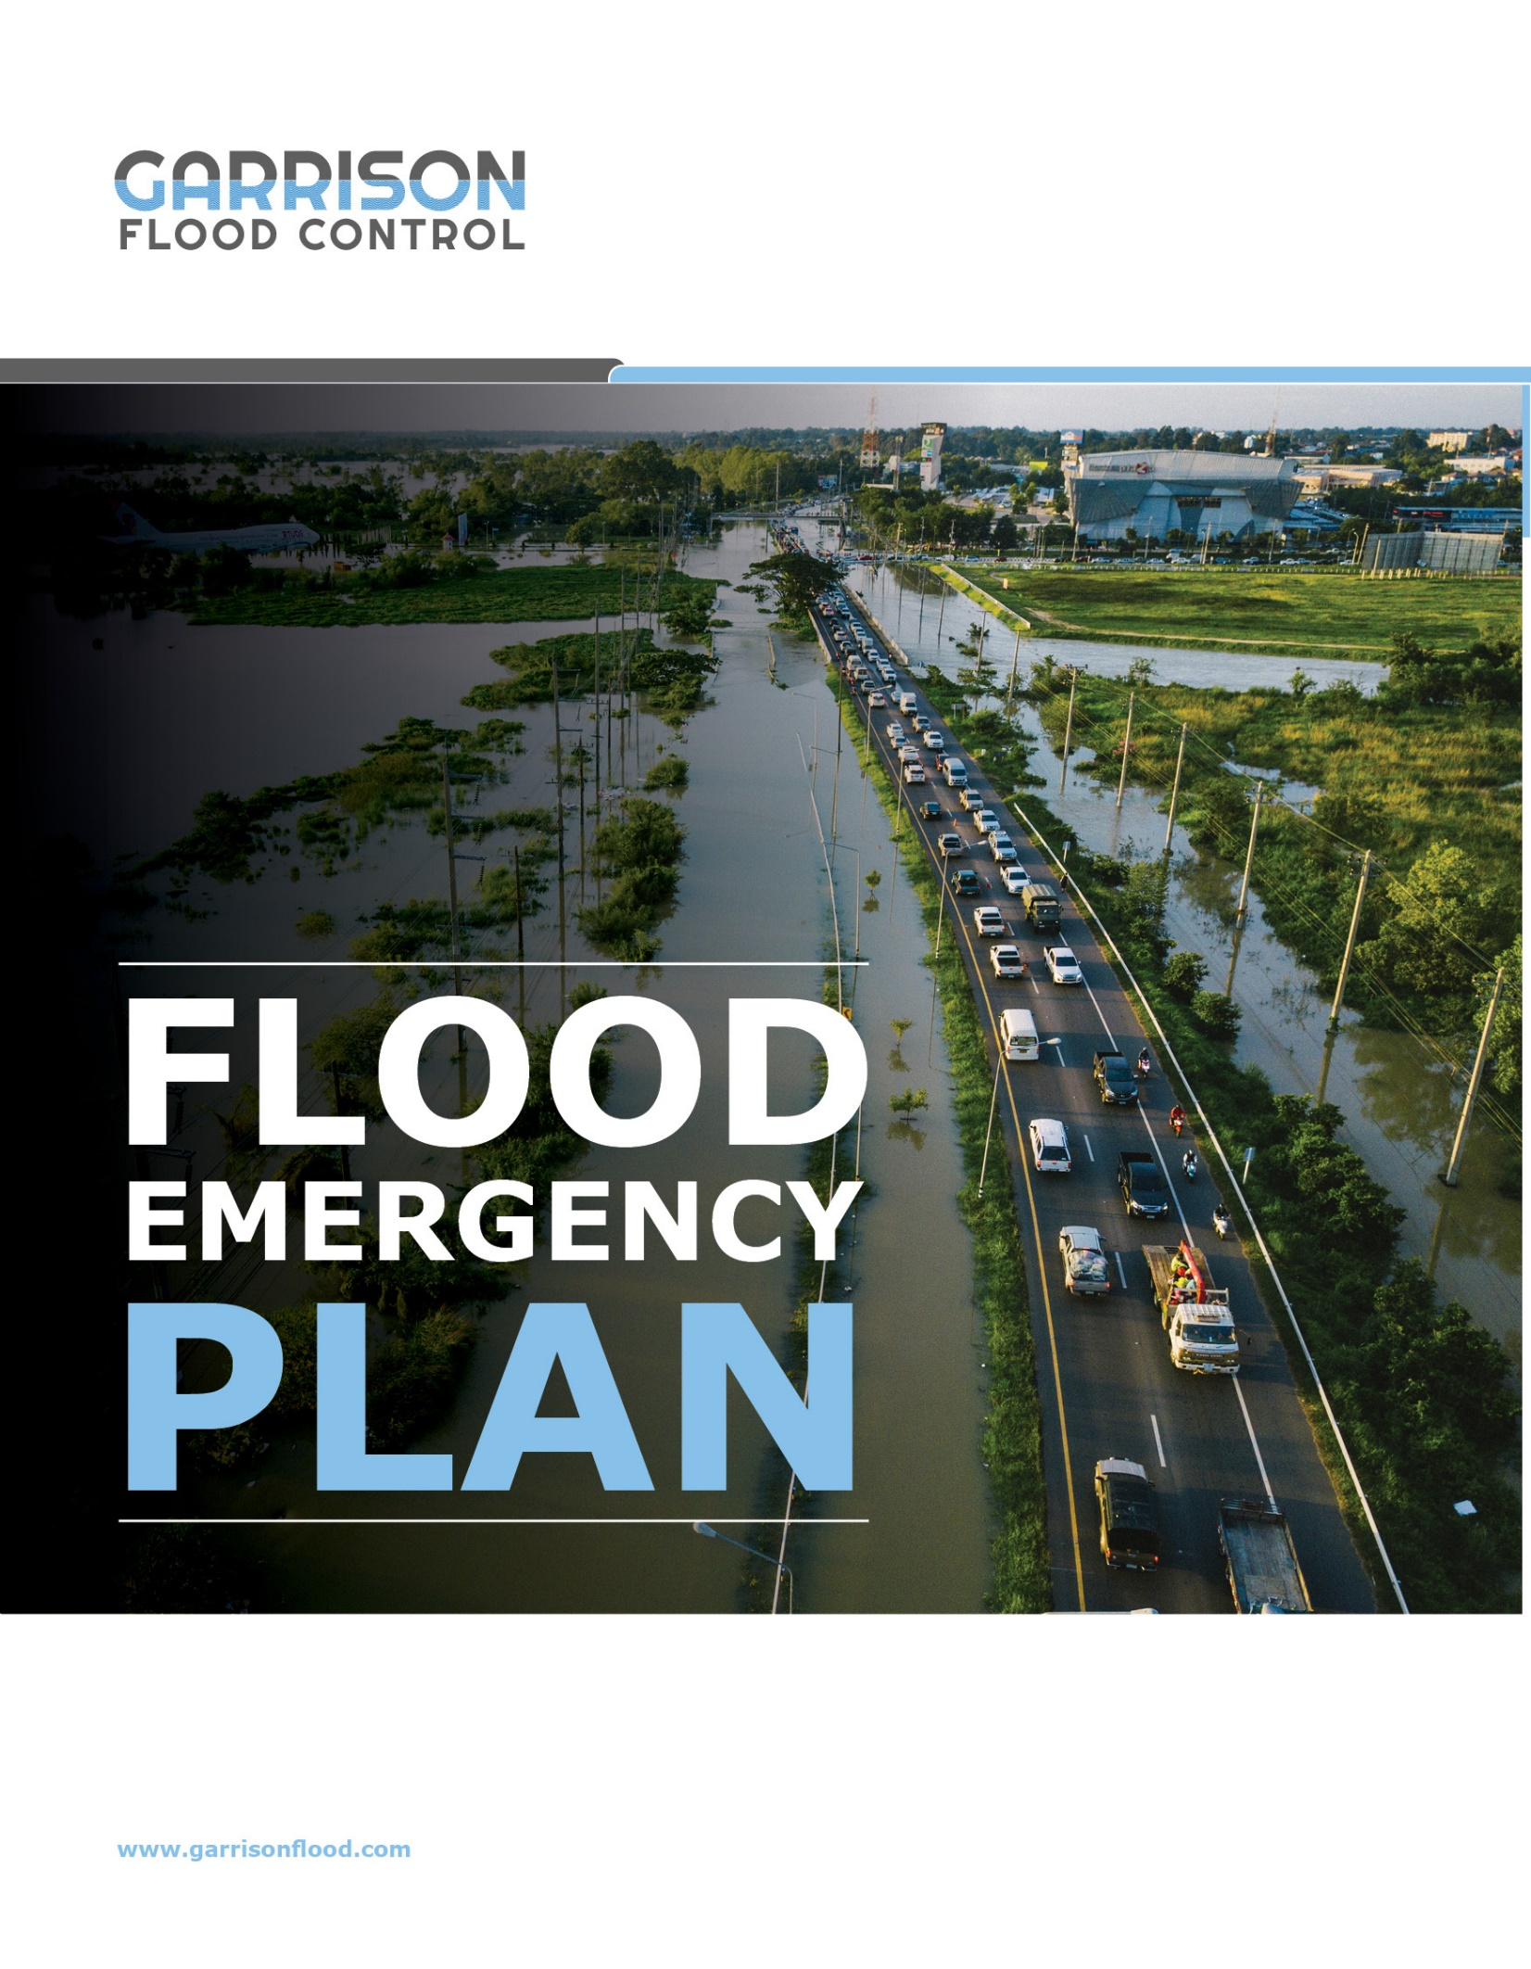

TABLE OF CONTENTS

- Purpose
- Site Flood Hazard
- Authority to Activate Plan
- Facility Contacts
- Local Emergency Contacts
- Key Contractors / Vendors
- Flood Monitoring
- Flood Action Plan
- Facility Shutdown
- Flood Mitigation
- Restoration of Operations (After a Loss)
- Post-Event Review
- Training Exercises
- Annual Review

- Purpose
This Flood Response Plan is an outline of actions to be taken before, during and after a flood. With proper planning, both property damage and business interruption can be minimized. The plan should be reviewed and updated annually to make sure effective action is taken, as needed.

- Site Flood Hazard
Flood hazards are unique and site specific. Understanding the potential scenarios faced by any individual site provides for the development of plan components that will be most appropriate with a higher level of success.
Provide a high-level description of the flood hazard(s) and likely scenario(s) including the following:
- Source(s) of flooding
- Likely weather event(s) that will trigger flood and time of year
- Likely advanced warning time for each event
- Depth of water if expected to effect site ingress and egress
- Depth of water expected in key buildings
- Length of time water will remain in the facility for each event
- Description of critical areas likely to be flooded
- Anticipated business impact
Describe the areas potentially affected and where the site is vulnerable to water entry. Each potential entry point should be listed in order of priority where water will most likely enter first. This will serve as a lead-in to describing the areas to monitor during any event.
Water Entry Points
Building / Area | Opening & Elevation | Notes

- Authority to Activate Plan

The authority to activate the plan is critical, as business operations may be temporarily halted and access restricted to reduce the overall damage and potential business interruption.

Describe who has the ultimate authority to activate response actions. Ensure an authorized person, such as a plant or operations manager, is responsible for each shift, and identify an alternate individual, as needed.
Authority to Activate Plan | Main Phone | Alternate Phone

Additional Contacts
Plant Contacts | Main Phone | Alternate Phone

Emergency Plan Coordinator

General Manager

Maintenance Manager

Security

Local Authorities | Phone Number | Website / Email

Police Department

Fire Department

Key Vendors | Phone Number | Website / Email
Garrison Flood Control | 929-299-2099 | GarrisonFlood.com / sales@garrisonflood.com

- Flood Monitoring
The plan should indicate when monitoring operations are to begin, the preferred method of monitoring, and who has the responsibility for this critical step. A person or position, with alternates, should be assigned to monitor local conditions on each shift.
Shift | Person / Position to Monitor | Alternate

Possible methods to monitor weather conditions leading to potential flood events include:
- The National Weather Service website: http://www.crh.noaa.gov/lsx/
- Special weather bulletins: http://www.weather.gov/view/national.php?thumbs=on
- Local emergency management agency
- Local TV stations
- Local TV station internet sites for weather radar
- On-site closed-circuit cameras focused on vulnerable points

Possible methods to monitor site specific water levels, rate-of-rise and projections include:
- If river – official river gauge forecasting sources (U.S. – Advance Hydrologic Prediction Service)
- If creek/stream/ditch – local gage, low breach points, observed water elevation to impact levels
- If bridges or culverts, monitor for obstructions leading to impoundment or diversion
- Low site drains in yard, dock areas, pits, basements, or sumps
- High-water alarms in low-level sumps, pits, etc.
- Consider installation of a localized water level gauge to monitor on or near site conditions

Specific water levels or precautionary predictions should be designated to trigger the action steps listed in the Flood Action Plan below. The trigger point should be based on the amount of time needed to accomplish the response action steps and the amount of advance warning time available.

- Flood Action Plan
This section should be completed by facility personnel. Items that should be considered and included are listed below. Specific action steps with the flood levels/predictions/local observations that trigger each step should be established and documented, along with required manpower and equipment for completion. This activity will help prioritize the tasks, which may be very important, if time is limited.
If the Response Plan includes deployment of flood protection equipment (barriers, gates/doors, sump pumps, etc.) and controlled shutdown of critical equipment, ensure each task necessary to implement the plan is documented and flood responders are assigned for all shifts.
Facility Shutdown
Procedure to shut down/de-energize utilities in an orderly manner to reduce ignition sources and damage:
- Plan for a safe emergency shutdown of operations
- Plan for shutdown of utilities (electric, fuel, etc.)
- Shut down ignitable liquid and flammable gas systems

Building / Equipment | Shutdown Activity | Time Needed | Assigned To | Water or Gauge Level to Begin Action

Flood Mitigation
Action Items are best prioritized considering the value of the mitigation action combined with achievability within the advance warning window available. Some typical examples not in any type of prioritized order are provided below:

- Control ignition sources.
- Stop all incoming shipments and expedite outgoing shipments.
- Raise and relocate highly valuable and easily moved equipment, contents and vital records to higher elevations. This may necessitate acquiring or renting special equipment to relocate contents. Rank level of importance.
- Close emergency valves to sewer drains.
- Check sump pumps to ensure they are operable.
- Deploy flood defense equipment such as barriers, doors and flood gates.
- Ensure backup power supplies (generators) are functional.
- Apply water-displacing, rust-preventive compound to equipment that may become partially or fully submerged.
- Fill empty storage tanks to prevent them from floating.
- Relocate/reroute supplies.
- Relocate/elevate critical files, stock, portable high-value equipment, etc.
- Set up emergency communication apparatus.
- Deploy site security. Monitor access to property and outside utilities during flooding.
- Begin communication to obtain portable temporary electrical devices, fans, dehumidifiers,etc., needed for salvage operations.

Building / Equipment | Mitigation Activity | Time Needed | Assigned To | Water or Gauge Level to Begin Action

- Restoration of Operations (After a Loss)
- Prioritize cleanup actions.
- Prioritize the rebuilding or replacement of pieces of equipment that are most critical.
- Contingency planning for prolonged site isolation:
  - Relocate operations
  - Set up temporary or skeleton operation at remote locations
  - Document procedures on how production will be made up at other facilities
- Establish agreements with vital sub-contractors to respond in the event of flooding.
- Initiate salvage and cleanup operations by a designated salvage crew. Focus efforts on:
  - Removing excess water, submerged carpet and wet equipment and contents, and washing down any mud or silt accumulations
  - Providing of high-volume fans and dehumidifiers to begin the drying process
  - Removing wallboard, or providing access panels to facilitate air movement within gypsum board, plaster or wooden walls
  - Initiating drying, cleaning and application of rust-preventive coatings to mechanical and electrical equipment
  - Relocating salvageable and undamaged stock and supplies to a safe area.

Building / Equipment | Restoration Activity (After a Loss)

- Post-Event Review
Review the plan after each flooding to identify areas for improvement, and to determine if any changes need to be made to the site and facility to reduce the magnitude of emergency actions.

- Training Exercises
Conduct regular Flood Response training exercises that involve all staff required to respond; and at least once a year, organize a complete dry run to simulate the flood event.

- Annual Review
Review the plan annually to confirm validity of its contents and the familiarity of personnel relied upon for its execution. Plan content may also be updated as facility changes occur.
- List of personnel involved with training and review of plan
- Date of annual review session
- Proper inventory and review of flood mitigation equipment, inclusive of but not limited to – flood barriers, dams, sandbags, sump pumps, fans and other equipment needed
- Updated document shared with key personnel

